**Assignment Number 6**

Register Number: 1740256

**Date:** 08/12/2018

--------------------------------------------------------------------------------------------**Question 1**

**Aim** – To obtain the regression coefficients and the lines of regression for the given data set car_sales.sav.

**Procedure -**

1. After entering the data into the SPSS data view, go to the analyse menu.
2. Go to the regression option in the drop-down menu that appears and choose linear.
3. Identify the dependent variable from the data set as well as the independent variable.
4. Drag the variables to the respective boxes. (dependent & independent) & click ok.
5. Choose the dependent variable x(in this case – sales in thousands) & the independent variable y(vehicle type).
6. The result will give the value of bxy as well as the corresponding value of the constant ‘A’.
7. Repeat steps 1-4 with the x & y variables exchanged i.e. sales in thousands as the independent variable & vehicle type as the dependent variable to obtain byx.
8. To find the lines of regression – substitute the values in the formula respectively –

X=a+bxyY

Y=a+byxX

**Calculations -**

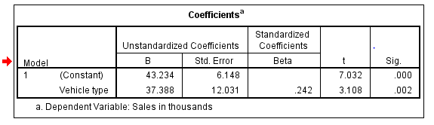

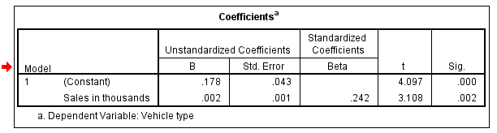

**Conclusion -**

The results of the regression coefficients between the type of the vehicle and sales in thousands are 12.031(X on Y) and 0.001(Y on X). Their corresponding lines of regression are X = 6.148 + (12.031)Y and Y = 0.43 + (0.001)X.

--------------------------------------------------------------------------------------------------------------------------------------

**Question 2**

**Aim** – To obtain the regression coefficients and the lines of regression for the given data set coffee.sav.

**Procedure -**

1. After entering the data into the SPSS data view, go to the analyse menu.
2. Go to the regression option in the drop-down menu that appears and choose linear.
3. Identify the dependent variable from the data set as well as the independent variable.
4. Drag the variables to the respective boxes. (dependent & independent) & click ok.
5. Choose the dependent variable x(in this case – image) & the independent variable y(brand).
6. The result will give the value of bxy as well as the corresponding value of the constant ‘A’.
7. Repeat steps 1-4 with the x & y variables exchanged i.e. image as the independent variable & brand as the dependent variable to obtain byx.
8. To find the lines of regression – substitute the values in the formula respectively –

X=a+bxyY

Y=a+byxX

**Calculations -**

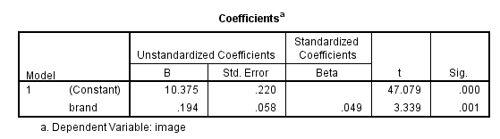

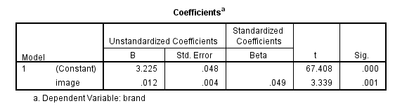

**Conclusion -**

The results of the regression coefficients between the image and brand are 0.058(X on Y) and 0.004(Y on X). Their corresponding lines of regression are X = 0.220 + (0.058)Y and Y = 0.48 + (0.004)X.

--------------------------------------------------------------------------------------------------------------------------------------